**Lab Report 1 - DENSITY**

Black line.

# XUAN MAI TRAN

01/16/2025

-

PHYS 2125

-

DR. JOSEPH BARCHAS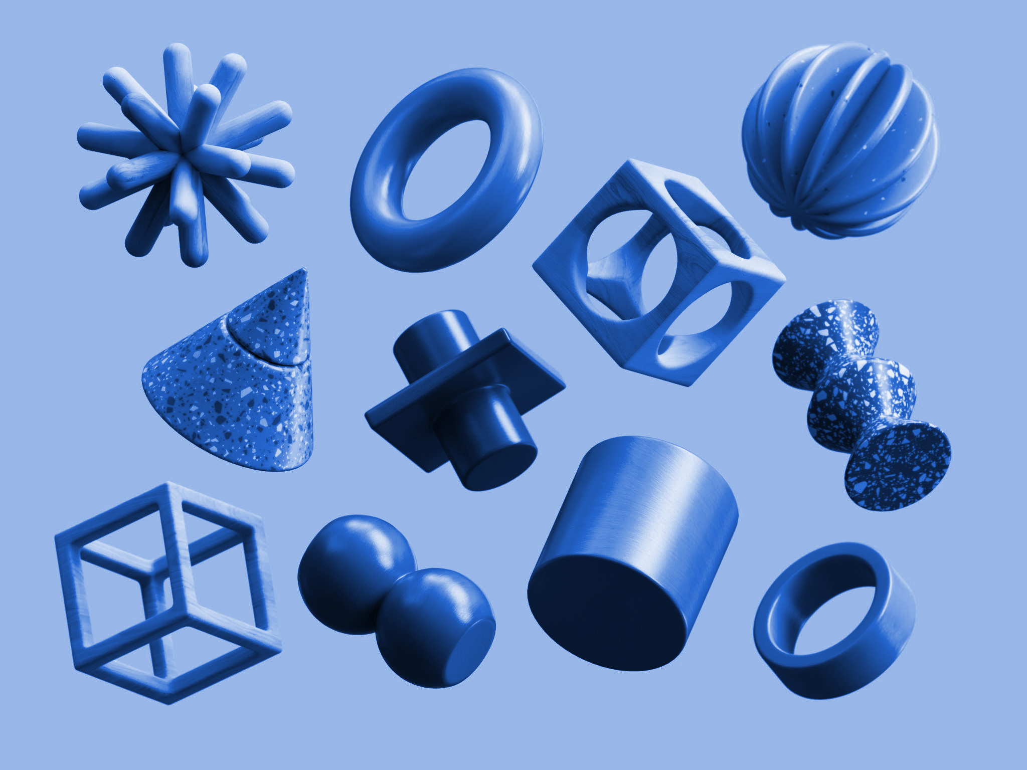

Objectives

To make basic calculations of the density of brass and aluminum, and then to improve these by using more accurate measurement methods.

Equipments

The list of equipments used in this experiment is:

* Brass Cuboid
* Aluminum Cuboid
* Brass Cylinder
* Aluminum Cylinder
* Aluminum Irregular Object
* Large Graduated Cylinder
* Ruler/Meter Stick
* Vernier Calipers
* Triple Beam Balance

Theory and Equations

There are 3 theories used to measure the density of the given 5 objects.

1. **Density**

To calculate the density (P) of an object which has a mass (M) and volume (V), we use the following formula: units: g/

1. **Volume**
2. **Measurement by a Graduated Cylinder**

The volume of an object can be measured using a graduated cylinder filled partly with water. The difference in volume before () and after () the object is placed in the graduated cylinder (the volume displaced by the liquid) equals the volume of the object.

**V =** units:

1. **Calculation by Geometric Formulas**

Volume of an object can also be calculated by using the linear dimensions of the object and geometric formula. The linear dimensions (l, w, h) or (d, h) can be measured using a ruler or a Vernier caliper. 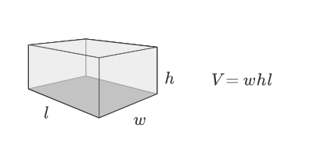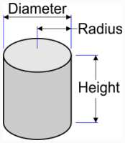

V = units:

1. **Percentage Error**

The percentage error is calculated based on the experimentally determined measure (exp) and the accepted value (acc). And there are 2 types of accepted values which are theoretical value which is predicted from theory and empirical value which is collected from a reliable source.

Percentage Error = * 100% units: %

Summary of Procedures

To calculate the density of the given 5 objects, we have to calculate the mass and volume of those objects using different methods. Therefore, we set up a stable surface with some measuring tools. Particularly, a Triple Beam Balance is used to measure the mass of the objects. To measure and calculate the Volume of the objects, we use 3 different tools, such as a 100 mL Large Graduated Cylinder, a Ruler/Meter Stick, and a Vernier Caliper. Specifically, the Large Graduated Cylinder is used to directly measure the volume difference of water to calculate the volume of an object. While the Ruler/Meter Stick and the Vernier Caliper are two methods used to measure the linear dimensions of an object and then calculate their volume.

Once we have the volume values ​​of the objects in the above 3 different cases along with their mass values, we can use the density formula to calculate the experimentally determined measurement (exp) in those cases. Finally, we calculate the percent error based on the accepted density (acc) of Aluminum and Brass in those different situations to see how much the accuracy improves when using different precision measuring tools.

Data and Observations

| Object | Mass | Dimensions  (by Vernier Caliper) | | | | Dimensions  (by Ruler/Meter Stick) | | | | Large Graduated Cylinder's Volume | |
| --- | --- | --- | --- | --- | --- | --- | --- | --- | --- | --- | --- |
| Length (l) | Width (w) | Height (h) | Diameter (d) | Length (l) | Width (w) | Height (h) | Diameter (d) | Before | After |
| Brass Cuboid | 66.0 g | 26.26 mm | 19.08 mm | 15.77 mm |  | 2.6 cm | 1.8 cm | 1.5 cm |  | 100 ml | 110 ml |
| Aluminum Cuboid | 66.3 g | 48.76 mm | 31.76 mm | 15.92 mm |  | 4.8 cm | 3.1 cm | 1.5 cm |  | 100 ml | 125 ml |
| Brass Cylinder | 207.6 g |  |  | 63.63 mm | 22.50 mm |  |  | 6.3 cm | 2.2 cm | 100 ml | 125 ml |
| Aluminum Cylinder | 66.4 g |  |  | 63.63 mm | 22.50 mm |  |  | 6.3 cm | 2.2 cm | 100 ml | 125 ml |
| Aluminum Irregular Object | 67.1 g |  |  |  |  |  |  |  |  | 100 ml | 125 ml |

Data Analysis

=

**Sample Calculation:**

Brass Cuboid:

* Volume (by Large Graduated Cylinder) = 110 ml - 100 ml = 10 ml = 10
* Volume (by Vernier Caliper) = 26.26 * 19.08 * 15.7= 7901.413416 / = 7.901
* Volume (by Ruler/Meter Stick) = 2.6 * 1.8 * 1.5 = 7.02 = 7.0
* Density (by Large Graduated Cylinder) = 66.0g / 10 = 6.6 g/ = 7 g/
* Density (by Vernier Caliper) = 66.0g / 7.901 = 8.35 g/
* Density (by Ruler/Meter Stick) = 66.0g / 7.02 = 9.4 g/

| Object | Volume (cm^3) | | | Mass | Density (g/cm^3) | | |
| --- | --- | --- | --- | --- | --- | --- | --- |
| by Large Graduated Cylinder | by Vernier Caliper | by Ruler/Meter Stick | by Large Graduated Cylinder | by Vernier Caliper | by Ruler/Meter Stick |
| Brass Cuboid | 10 | 7.901 | 7.0 | 66.0 | 7 | 8.35 | 9.4 |
| Aluminum Cuboid | 25 | 24.65 | 22 | 66.3 | 2.7 | 2.69 | 3.0 |
| Brass Cylinder | 25 | 25.3 | 24 | 207.6 | 8.3 | 8.21 | 8.7 |
| Aluminum Cylinder | 25 | 25.3 | 24 | 66.4 | 2.7 | 2.62 | 2.8 |
| Aluminum Irregular Object | 25 |  |  | 67.1 | 2.7 |  |  |

Results

**Accepted Value:**

| Accepted Density of Aluminum: | 2.7 g/ |
| --- | --- |
| Accepted Density of Brass: | 8.73 g/ |

**Sample Calculation:**

Brass Cuboid:

* Percentage Error (by Large Graduated Cylinder) = * 100% = 19.8167 = 20%
* Average value of Percentage Error (by Large Graduated Cylinder) =

= = 4.98% = 5%

| **Object** | **Percentage Error (units: %)** | | |
| --- | --- | --- | --- |
| **by Large Graduated Cylinder** | **by Vernier Caliper** | **by Ruler/Meter Stick** |
| Brass Cuboid | 20 | 4.4 | 7.7 |
| Aluminum Cuboid | 0 | 0.37 | 10.0 |
| Brass Cylinder | 4.9 | 5.96 | 0.69 |
| Aluminum Cylinder | 0 | 3.0 | 2.6 |
| Aluminum Irregular Object | 0 |  |  |
| **Average Value** | **5** | **3.4** | **5.2** |

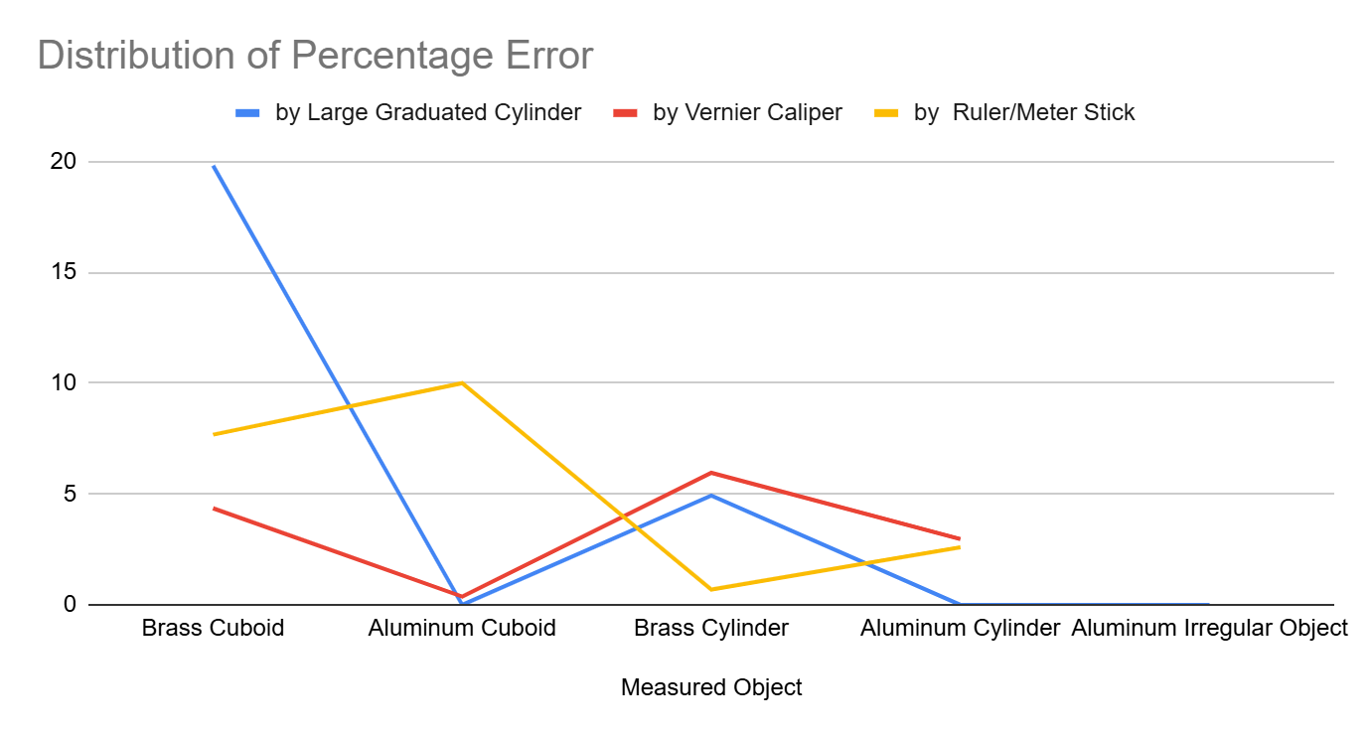

Discussion / Conclusion

We can determine the density of brass and aluminum materials using three methods: Large Graduated Cylinder, Vernier Caliper, and Ruler/Meter Stick. By calculating the percentage errors and comparing these methods, we gain insights into their accuracy and precision.

From the results, it's evident that the Large Graduated Cylinder has the highest average percentage error with the least significant figures. This outcome is reasonable, as the wide spacing between its marks requires manual measurement of the water volume by eyes, leading to highly potential inaccuracies and human errors. While the Ruler/Meter Stick shows some improvement by utilizing the geometric formula, its precision is limited to one decimal place of a centimeter. In contrast, the Vernier Caliper shows a higher precision with measurements accurate to 2 decimal places of a millimeter.

Moreover, all three methods seem to yield higher accuracy for Aluminum objects compared to Brass objects. Surprisingly, the Large Graduated Cylinder states extremely high accuracy for different aluminum objects, with 0% percentage error. However, it shows significant errors for brass objects, likely due to human error and the distant marks on the cylinder.

Additionally, it is observed that materials with higher density (Brass) tend to produce higher percentage errors compared to materials with lower density (Aluminum). This may be attributed to the formula for density, which is the division of mass to volume. The explanation may be that a measurement tool with low precision that introduces a small error in volume may result in a higher overall measurement error.

In conclusion, using higher precision measurement tools is highly suggested to improve the accuracy. Specifically, a Graduated Cylinder with smaller and more detailed spaced marks would produce the higher reliability of measurements.

Post-Lab Question

Density formula: (P: density, M: mass, V: volume)

= (a: side length of a cube)

* Following the question, we have the value of Accepted Density of Aluminum is 2.7 g/ and the required mass of the cube is 1.00 kg. Applying the Density formula, we have:

Cube’s Side Length of Aluminum:

* Similarly, we have the value of Accepted Density of Brass is 8.73 g/ and the required mass of the cube is 1.00 kg. Thus:

Cube’s Side Length of Brass: